Attention:
Lisa Radtke, Township Supervisor
supervisor@Fifelaketwp.com
134 Morgan Street
Fife Lake, MI 49633

Re: Headquarter Dam – Research, Status and Operation Recommendation

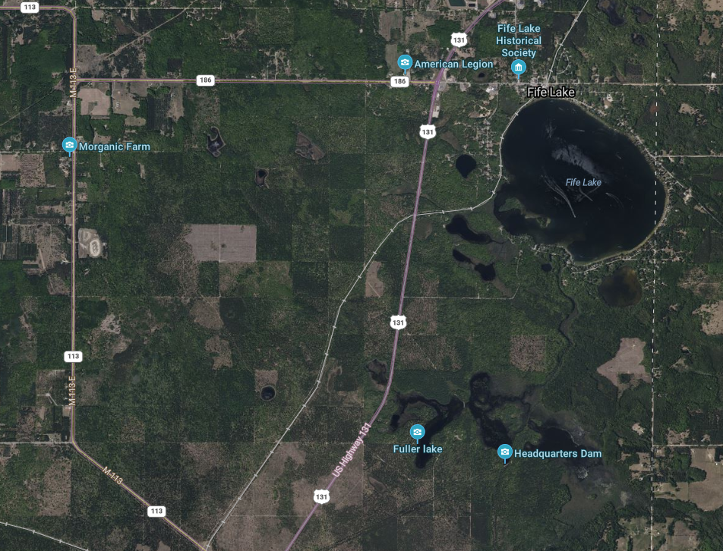
Fife Lake is 36 square miles with 1.6 square miles of surface water, situated in the southeastern portion of Grand Traverse County. Part of the Manistee River Watershed, there are two (2) inlet streams that flow into Fife Lake, one (1) originating from Spring Lake and the other is spring fed. The later, known as Fife Lake Outlet, is impounded by a dam that creates Headquarter Lake approximately 2 miles to the south. This outlet is a designated trout stream below the Dam. This dam, named Headquarter Dam is
is regulated by the Michigan Department of Environment, Great Lakes and Energy (EGLE) and owned by Michigan Department of Natural Resources (DNR).
A current assessment of the infrastructure was recently conducted by an outside consultant and the DNR is contemplating options. Fife Lake Township has requested GFA, as their Engineer, to provide a technical memo on the subject matter.

Data GFA reviewed including online resources and documentation provided by the Township

- 2014 DNR Status of the Fishery Resource Report 2014-181
Report covers the fishery details for Fife Lake itself and identifies the “Fife Lake Outlet”, natural stream, which drains to Headquarters Dam creating Headquarters Like. Fife Lake Outlet is a designated trout stream below the dam.

- March 2021 EGLE Headquarters Dam Safety Inspection report and recommendations.
The report recommends outlet pipe corrective measures as well as developing a monitoring plan on the seepage at the toe of embankment/slope stability. In addition, report contemplated and considered plan for removal if the dam does not provide significant benefit.

- 2024-02C5-SOM DTMB Headquarters Dam Evaluation – Phase 100 Study RFP
State of Michgina solicited a Request for professional design services including study phase and cost estimation for the future design and construction services for proposed to address existing issues (outlet pipe and embankment). Proposal included the following options: 1) Dam replacement, 2) full removal, and 3) installation of culver and lowering grade to historic elevation.

- Headquarters Lake Flooding Wildlife Management Area Map
Map indicates the current 424 flooding acres across the State Forest / State Wildlife/Game

- Michigan Dam Inventory Mapper indicates fair condition and Hazard Potential Classification is Low - no loss of life, minor impacts.
Historical Background:
The dam was constructed around 1955 as earth embankment to impound approximately 185 acres of surface water at a depth of four (4) feet. The levels are manually controlled using stop logs and replaced as needed to ensure structural integrity. It was constructed to maintain and preserve wildlife habitat and is used primarily for recreational purposes. The dam currently attenuates the peak flows from the contributing watershed.
The DNR, as the owner of the dam, is responsible for performing inventory, maintenance and inspection of their infrastructure as required by Part 315 Dam Safety regulations enforced by EGLE. Based upon a recent inspection performed in September 2020 the dam was found to be in fair overall condition with no structural deficiencies noted. A few maintenance items were noted including mowing, tree and debris removal, culvert pipe upgrades and additional monitoring were identified. Furthermore, there were references within the inspection report for the DNR to consider long term.
- Implement Dam Repairs/ Maintenance: Address future embankment condition to address age, seepage, and slope stability.
- Alterations to Dam: Installation of culvert and lowering grade to historic elevation
- Dam Removal: If determined to not provide a beneficial use

In 2024, the DNR through the State of Michigan DTMB publicly solicited a proposal seeking professional services to provide a study including evaluation, cost estimates and recommendations relevant to the options. The results of that report were not available as of this document.

GFA Review and Considerations
It seems reasonable that improvements to the Dam are necessary for long-term function and structural integrity based upon the documentation reviewed. In addition, considering the function and level of service provided by the Dam coupled with routine costs for operation, maintenance and upgrades, it also seems prudent for the DNR to further investigations options available as part of their due diligence.
In summary, all three (3) options considered and/or implemented pose have varying effects related to water levels in the impoundment area, increased peak flows to the downstream reach, and head cutting upstream through the former impoundment and downstream erosion until the stream achieves natural equilibrium. Restoration and/or alterations to the existing dam seem appropriate and straight forward to sustain the existing watershed and ecosystem. Therefore, we offer the following feedback and considerations with respect to decommission and abandoning of the dam as it would seem to be the more extreme of the three (3) options.
We performed a cursory review of the public imagery on the county parcel mapper and topographic quad maps to further review areas service and potential impact. The land cover within the watershed upstream of Headquarters Dam has remained relatively constant over the years. A review of existing site conditions and surface features indicated no waterfront properties on the current impoundment areas with no adjacent development seen until East County Line Road, approximately 2 miles downstream of the Fife Lake Outlet. Overall, it is anticipated that the upstream changes in water levels and potential for head cutting would be isolated and would not affect Fife Lake. The existing natural channel and slope of the “Fife Lake Outlet” should be able to accommodate an increase of flows.
Unfortunately, this assessment is preliminary and additional hydraulic information is critical to provide and firm conclusions and recommendations. The results from the 2024-02C5-SOM DTMB Headquarters Dam Evaluation – Phase 100 Study is expected to provide more detail and defined upstream and downstream effects.

We appreciate the opportunity to assist the Township with the project as this project develops. If you have any questions, please don’t hesitate to contact us.

Respectfully Submitted,

GFA

Jennifer Graham, PE

Mark Maguire, PE

